
Koneru Lakshmaiah Education Foundation
(Deemed to be University estd. u/s. 3 of the UGC Act, 1956)
Off-Campus: Bachupally-Gandimaisamma Road, Bowrampet, Hyderabad, Telangana - 500 043. Phone No: 7815926816, www.klh.edu.in

STUDENT CASE STUDY EXECUTION REPORT
Department | FED
Sub'ect | DSA-2
Academic Year | 1-III Semester | 2025-26
Facult Name | Mohd.Razia
Student Name | U.Shiva Reddy
Roll Number | 2520090172
Branch | CSIT
Course Outcome | CO-1
Case Study Topic: Athlete Performance Record Management using AVL Tree
Work Done Summary:
In this case study, we implemented an AVL Tree for managing athlete performance records in the SportsAnalytics system. Each athlete record is stored using Athlete ID as the key. The AVL Tree maintains balance automatically during insertions and deletions, ensuring efficient searching and updating of athlete data.
We inserted athlete records, performed search operations, updated performance statistics, and observed AVL balancing operations such as LL, RR, LR, and RL rotations. The system ensures fast retrieval of athlete information even when the number of records increases significantly.

Implementation Details:
- Created an AVL Tree structure using Athlete ID as the node key.
- Inserted athlete records into the AVL Tree.
3. Maintained balance using AVL rotations whenever imbalance occurred.
- Implemented search operation to find athlete performance details.
- Implemented deletion operation for retired or inactive athletes.
- Compared AVL Tree performance with a normal BST.
- Verified that AVL Tree operations maintain O(log n) complexity.

Result: Screenshots / Output
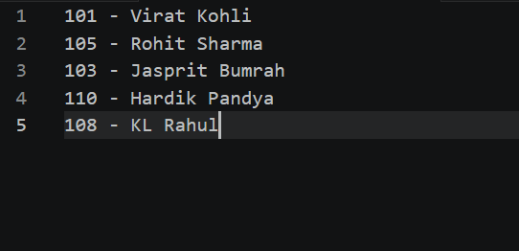
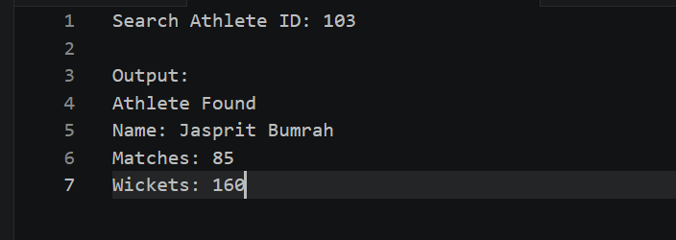
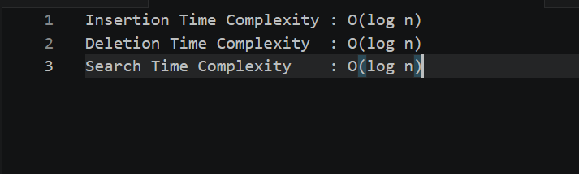

The AVL Tree provided efficient insertion, deletion, and retrieval operations. Compared to a traditional BST, the AVL Tree maintained balanced height and ensured faster access to athlete performance records.
GitHub Link: https://github.com/Shiva77661/SportsAnalytics-Athlete-Performance-Tournament-Management-System/blob/main/class%20AthleteNode%20%7B.txt
Student Signature Faculty Signature

